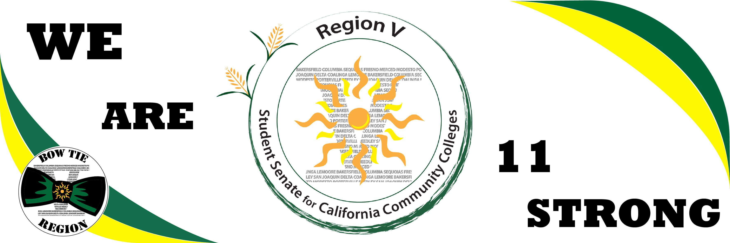

Region V Time Line

# Time Line of Success

Elections!

June 6

Columbia College

Region V

Evaluations

May. 9

Willow International

GA- Resolutions

Opposition to “Regional Senator”

May. 3

All ASO/ASG Recognized

SSCCC Reconstruction

April 11

Fresno City College

Articles of Incorporation

Mar. 21

Teleconference

In House Rearrangement

Feb. 21

Columbia College

State Legislation Review

Jan. 31

Porterville College

Region V Evaluations

Dec. 20th

Fresno City College

Continued Revamp

Nov. 15th

Delta College

Fall GA

Resolutions

Nov. 2

Region V Logo

Oct. 11

Columbia College

Ab 1358  
Ab 955

Sept 20th

Reedley College

Region V Revamp

August 8th

Modesto Junior College

Defined Goals

July 19th

Bakersfield College

- Attribution